**Prototype Checklist:**

Specifically for airplane (during setup):

* Assign just one computer in which the ardupilot software will run. Make sure all modifications and or corrections are done on that SAME computer no matter what the situation is.
* Make one mission profile for each possible wind scenario (4 in total, depending on the orientation of the wind).
* Make sure that the pitch angle given and the first actual mission point distance from home actually make sense (if 50 m are needed, make sure that the pitch actually can achieve that), as well as with the landing.
* Prepare the starting position of the aircraft to be in the middle of the field and not in one of the edges, so that if necessary, an abortion can be made having an airplane within the field.
* The aircraft will ALWAYS start from the center and follow a predictable north or south heading that can be easily seen by the pilot and launcher.
* Try to give enough margins for the aircraft to maneuver within the terrain. DO NOT make the mission profile too close to the edges, so that the person has time to see the aircraft.

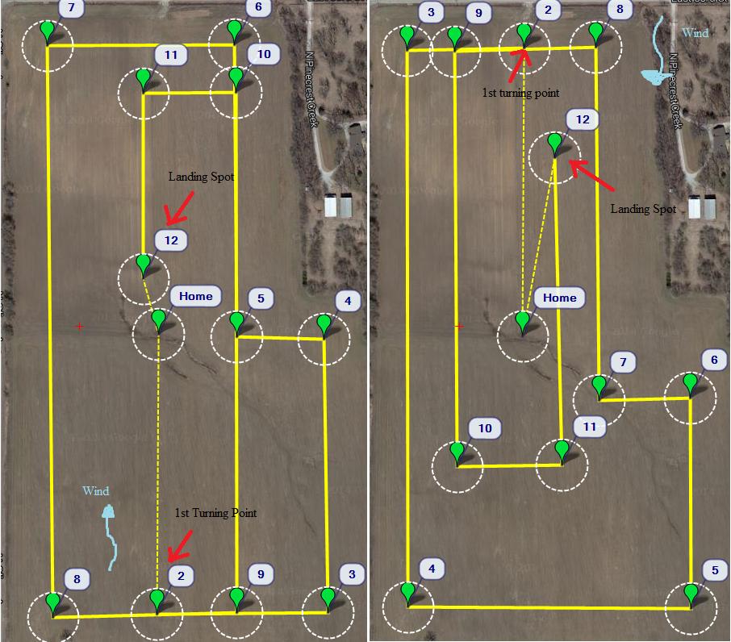

Figure : Example of Two different wind-dependent files ready to use

* Weight with accuracy every component to add before an external modification.
* Make sure that the CG stays where it is supposed to stay.
* Make sure that the autopilot could be connected without having to take it out of its current package.
* Take the empty weight of the aircraft and predict the performance if possible.
* If possible, put two different colors on the top of the wings to distinguish the right from the left, so that the pilot has an idea which wing is which in case it is too far away from the home position.
* Make three different folders. One for ‘Pre_mission_flights’ including the created paths and configuration files of prospective missions, other with mission type and date which contains the files to be used the day of the mission, and finally other folder with the name results and date for telemetry and imaging results of the completed/failed mission.

Before Flight (about a day before)

1. Make sure the necessary batteries and GPS equipment is working. For that, test each component separately, making sure there are not glitches, mainly on the autopilot gain system, the receiver/transmitter and the speed controller. □
2. Check the mission points and routes. Check that the altitude and heading make sense for the type of the mission that is going to follow. Save those files with the name of the mission and date in a common folder (e.g Loop_flight_west.path on ‘loop flight 02/12/2015’) □
3. Check the camera profile. Make sure that the ISO is correct and the timer is set up right. Test the SD card and check for bugs in the recording of the data. □
4. Make sure the data flash log configuration on the mission planner contains all the necessary parameters for the recording of the wanted parameters. □
5. Test the servos and both the longitudinal and lateral balance of the components. Make adjustments if necessary. □
6. Look at the structure and make sure every part is soundly mounted. Make sure that there are no loose screws or flimsy lifting surfaces. □
7. Calibrate the radio controller with the assigned laptop to the model. □

During Flight (The same day)

1. Allow for 2 extra hours in the field to prepare the systems and check the flight conditions. □
2. Prepare the laptop assigned to the airplane with all the required data of the flight day. □
3. Quantify the wind by checking the weather station near the flight field. Make sure that the wind is LOWER than 8mph and that the heading is within the projected scenario. □
4. Load the pre-made waypoint file inside the ardupilot which makes possible its flight with takeoff and landing against the wind. You must choose one of the pre-made flights. □
5. As soon as the pre made flight scenario is loaded, place the aircraft in a level position and calibrate the accelerometers directly. This also could be done the day before, provided that the interface of the current model doesn’t require taking the autopilot out for configuration. □
6. Make sure physically that the previous point is the case (just tilt the airplane and watch its level position and corrections). □
7. Make sure that the switch toggling the flight mode works properly by looking it up on the laptop. □
8. Once all the connecting procedure has been verified, disconnect the USB cable and proceed with the radio range check. □
9. In the radio range check the person holding the airplane will stand in one side of the field, while the other person stands at the other, to make sure that the airplane is savable throughout the field. Since the reference range is 0.4 miles that should suffice to cover all the terrain. □
10. Check radio failsafe. Channel 5 will change the flight mode, whereas channel 6 will be in charge of the failsafe switch. Turn on the failsafe switch and make sure that the airplane goes into failsafe mode, bypassing the autopilot system entirely. □
11. Toggle the different flight modes with the transmitter. Make sure that the response obtained matches the expectations. □
12. Turn throttle to full. Make sure the propeller stays in place and there are no loose parts on the airframe even at full throttle. □
13. As soon as all the flight checks are in order, and if the mission allows for an extra amount of range, proceed to fly manually the plane, looking for problems in trimming and stability. The flight must at least be two laps long and/or two minutes. The airplane must be full loaded and trimable to proceed. □
14. For this first flight, both the launcher and the pilot will stay at the center of the field. The pilot will engage 0.75 throttle and the launcher will launch it. The pilot will then proceed to make turns around its location, at a tolerable altitude for complete visibility. □
15. As soon as the manual flight is done, and if all the systems are complete, proceed to prepare the mission. □
16. Put a flag on the first turning point of the mission as reference for the pilot and launcher. □
17. Engage the camera with the pre-loaded script. Start moving towards the center (for the launcher) and the first mission point (for the pilot). □
18. For that, the launcher will sit at around the center of the field, whereas the pilot will be standing next to the first turning point of the airplane. That way if the airplane does not turn the way it is intended to, the pilot can then engage emergency procedures (manual or failsafe. NO RTL). □

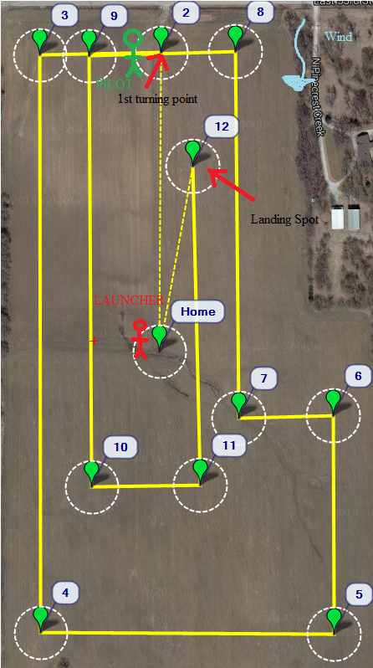

Figure : Position of launcher and pilot in hypothetical mission

1. If the aircraft completed successfully the first turning point, the pilot will follow the aircraft towards a more central position. Make sure that the aircraft follows the intended pattern. □
2. If takeoff and/or altitude heading are obviously wrong, abort the mission immediately. □
3. If there is any control bias from the airplane not explainable by the mission profile selected (unexpected turn) terminate the mission. □
4. If the mission is completed, proceed to watch the landing. If the landing procedure fails, or the landing velocity seems too fast for a safe landing, the pilot has to take control of the airplane and do an emergency landing. □
5. If the mission finishes, no matter whether was a success or a failure, disarm the airplane and proceed to take the airplane off the field. □
6. Proceed to gather the data flash logs and the SD cad on the laptop for analysis, in the third folder. □